**On estimation of total length of single light wave emitted by Sodium atom using air-wedge method**

**Ghanshyam Jadhav**

**Dept. of Physics, Shri Chhatrapati Shivaji College, Omerga-413606, India**

**Email: Email: ghjadhav@uniphysics.org.in**

**Web:** [**www.uniphysics.org**](http://www.uniphysics.org)

While dealing with wave nature of light, we know its wavelength, frequency and speed. We don’t know yet about the total length of the light wave at the instant when it is emitted by an atom. The time taken by an electron for transition from its higher energy level to lower energy level in an atom should be finite. Therefore, the total length ‘L’ of the light wave emitted in this process should be finite. However, it could be how much long for a particular transition of the electron is not estimated yet.

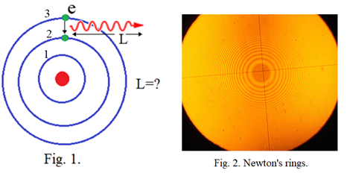

The Newton’s ring experiment is generally performed to determine average wavelength of sodium light. Typical students are always interested to know how many rings are formed there just because of their curiosity. They face difficulty due to decreasing width of the rings going away from the center where the colour gets diffused more and more. How many rings should be formed there, in fact, gives important message about the total length of the single light wave involved there and is being ignored always.

However, instead of using Newton’s ring experiment, we can use the air-wedge method where the fringe width remains constant all over which ease to estimate how many fringes are being formed for a given monochromatic light source. However as the path difference increases the fringe colour gets diffused and diffused and lastly becomes difficult to discriminate bright and dark fringes. Therefore, we have approximately estimate the total number of fringes formed there.

**Number of lines emitted by sodium atom:**

Here we describe how one can estimate the total length of single light wave emitted by a sodium atom using simple air-wedge method.

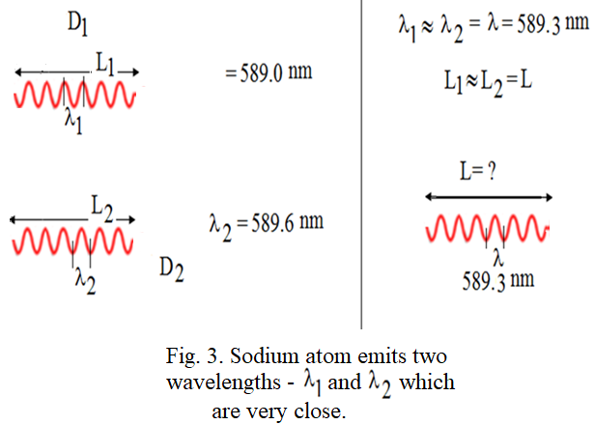

**Air-wedge method to determine total length of single wave emitted by sodium atom:**

Air-wedge method is generally used to measure thickness of a thin wire using a monochromatic light of known wavelength. Our interest is to measure total number of fringes formed there [1]. Corresponding experimental arrangement is shown in fig.1. Instead of a thin wire placed between glass plates G2 and G3, a cover slip usually, used in biology lab, may be placed to obtain suitable air-wedge producing distinguishable fringes to count without difficulty. A sodium lamp is used as a monochromatic light source. Actually, sodium light has two wavelengths with extremely close to each other as described in fig.2. The air-wedge method cannot discriminate such small difference in wavelength and treats as waves of one average wavelength is nm. Further, we expect that, once a wave, either having wavelength  nm or nm emitted by a sodium atom should have a finite total length as shown in fig. 2. Our attempt is to find the total average length L in vacuum, with assuming that L1=L2=L, of single wave of sodium light. For that, we go systematically in following way.

No. of waves are emitted simultaneously by sodium atoms constituting the sodium lamp. Each wave has finite total length L. With reference to figure1, every single wave A emitted from sodium light source has total length L. Every wave A is partially reflected and refracted at glass plate G1.

The corresponding partially reflected wave B has same total length L. Further every wave B is responsible to produce corresponding wave 1 reflected at lower surface of glass plate G2 and wave 2 reflected at upper surface of glass plate G3. Therefore, wave 1 and wave 2 have same total length L. Every wave 1 and corresponding wave 2 contributes to the formation of dark and bright fringes. At contact point B of glass plates G2 and G3, there is no phase difference between wave 1 and wave 2 where first bright fringe is formed. Going from point P1 to point P2, the phase difference between wave 1 and wave 2 increases and becomes half wavelength, consequently the waves come in out of phase with each other and form a dark fringe. Here wave 1 lags behind the wave 2 by distance half wavelength.

Further to right of that, the path difference between the two waves increases and becomes one wavelength, where the two waves, once again, come in phase with each other and form second bright fringe. In this way, when we go from point P1 to point P2 the path difference between wave 1 and wave 2 increases forming dark and bright fringes alternatively. A point will reach at which the path difference between the two waves becomes L where there is no formation of fringes as the two waves become separate. While counting the fringes, the telescope is scanned along x-axis and the lamp is also kept on the same axis so that the beam intensity is maintained.

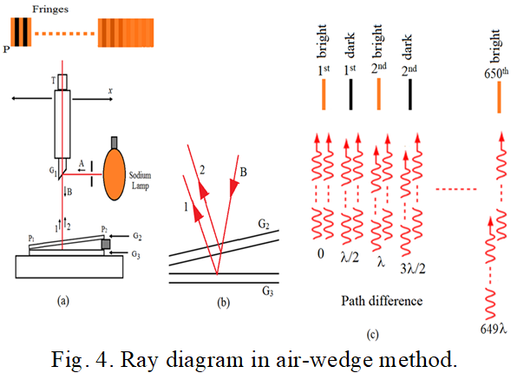

Counting total number of bright fringes multiplied by wavelength of the wave gives the total length of wave 1 or of wave 2 which is equal to the total length of wave A. However, the overlap portion of wave 1 and wave 2 reduces as the path difference between them increases. Therefore, practically it becomes difficult to estimate exact total number of bright and dark fringes formed in this system, especially in the region where the wave 1 and wave 2 are close to become separate. However, approximate estimation of total number of fringes can be done which gives the approximate estimation of total length L of the wave A. We could thus approximately estimate formation of 650 number of bright fringes for sodium lamp by using air-wedge method in undergraduate physics laboratory.

**Results:**

Total number of bright fringes formed are *n,* then the total length of the monochromatic single light wave is *L= n l*. Here total number of bright fringes formed are 665. Therefore, total length is,



The total length of the light wave emitted by sodium atom is 0.383mm and is very long.

How such long wave can act as a single photon how it can be absorbed by a single electron is amazing. Since electron size is simply 0.1nm.

**Combination of two waves to form a single wave:**

At first glance one cannot expect that a sodium atom is emitting wave having total length approximately equal to 0.383nm. It means that there can be possibility of two or more waves that are joined together to form a chain of waves consequently the actual wave emitted by the sodium atom and the wave A, who is taking part to form the fringes, may be different from each other. This can happen as there are number of sodium atoms enclosed and distributed in the sodium lamp which are emitting light waves simultaneously. To check this possibility, we consider combination of two waves in different ways to form a chain of wave as illustrated in figure 5.

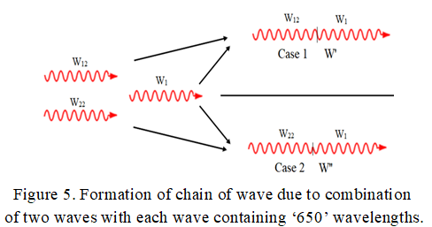

Wave W1 and wave W12 emitted by two different atoms are joined in their journey such that they form a single wave W’ as illustrated there. Suppose there are 650 number of wavelengths in waves W1 (same in waves W2 too) then 650 number of bright fringes are formed by this wave. Further, at the place of 651th fringe, the wave W’ forms a bright fringe as shown by case 1 in figure 6(a).

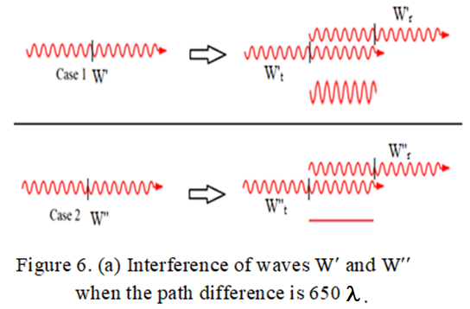

At the same time the resultant wave W’’ forms a dark fringe at the same place as shown by case 2. For further path difference of half wavelength they will interfere such as illustrated in figure 6(b). At this place the wave W’ forms a dark fringe whereas the wave W’’ forms a bright fringe. Thus, in the further region only dark or bright fringes cannot be formed. We have taken two typical cases of waves W’ and W’’ for examination. It is true for all possible combinations of the waves emitted by the sodium lamp. Hence, the total length, 0.383mm, of the wave A obtained in this experiment should be the actual total length of the wave emitted by the sodium atom in the lamp.

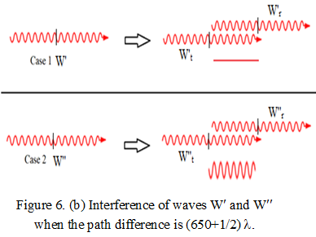

**Discussion:**

According to the classical electrodynamics, one oscillation of electron should emit wave containing one wavelength. Two oscillations of electron should emit wave containing two wavelengths. Therefore, if a wave containing 650 wavelengths, then the corresponding electron should be oscillated 650 times while producing the wave. It is amazing. Therefore, the light emission mechanism in atoms is yet to be understand properly.

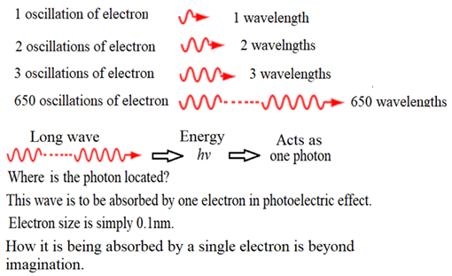

Further, the total length of a wave can depend on the size of the emitting atom, temperature of substance, state of the substance-gas or liquid or solid etc. Different monochromatic light sources can be used to find the total length of their light waves. From any light source, a monochromatic light wave can be also isolated to determine its total wavelength. Such data may give new information about the light emitting mechanism of the atoms.

**Conclusion:**

The total length of single light wave emitted by a sodium atom is 383045nm approximately and is very long.

**Reference:**

1. G. H. Jadhav and Shivanand Kalshetty, ‘On estimation of total length of sodium light wave using air-wedge method’, Presented in ICAES2021 and accepted for publication in AIP proceeding, 2021.

----------------------------------------------